Assignment 5

Marks for Assignment 5 total 80 (10 marks for each question).
- Answer the following questions:
- Identify the 1°, 2°, and 3° hydrogen atoms in 3,3,4-trimethylhexane.
- Give the IUPAC name for each of the following:
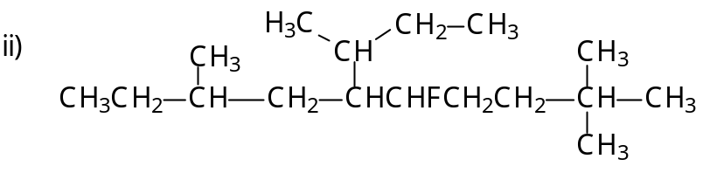
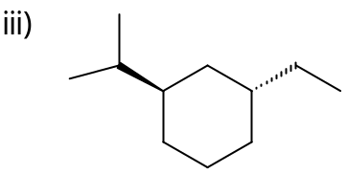
- The following structures are incorrectly named. Briefly explain the error and give the correct name for each.
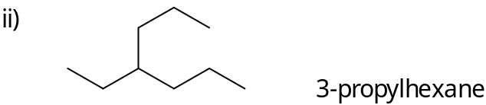
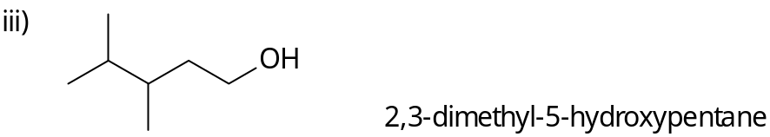

- For each of the following cyclohexane derivatives, indicate whether the molecule is a cis or trans isomer, and whether it is in its most stable configuration. If the molecule is not in its most stable configuration, draw the most stable configuration you would get if you “flipped” the ring.
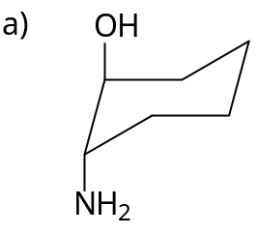
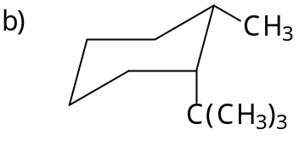
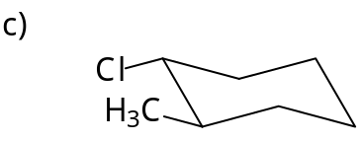

- The anti conformation of 1,2-dichloroethane, CH₂ClCH₂Cl, is 4.8 kJ·mol^{–1} more stable than the gauche form. The two energy barriers (relative to the energy of the gauche form) for the C—C bond rotation are 21.5 kJ mol^{–1} and 38.9 kJ mol^{–1}.
Construct a graph of potential energy versus angle of rotation (similar to Figure 2-13 in your textbook) for 1,2-dichloroethane. Show the energy differences on your graph. Draw a Newman projection formula to indicate the conformation present at each maximum and minimum on the graph.

- For each of the nine compounds listed below, complete the following:
- List those that are chiral.
- Indicate the asymmetric carbon atom(s) in each of the molecules you identify as chiral in a).
- Draw one of the stereoisomers of each of the chiral molecules in part a) and assign it the correct (R) or (S) designation.
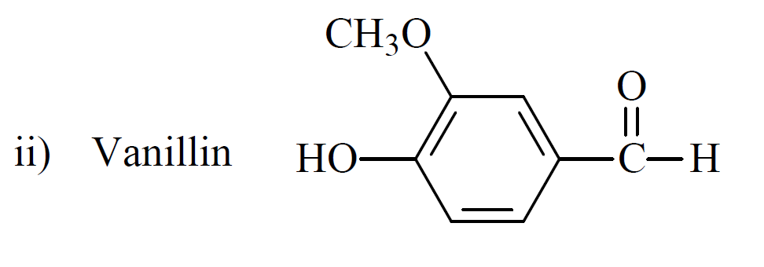
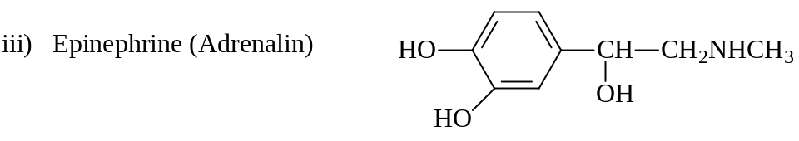
iv) 2-methylheptane
v) 3-methylheptane
vi) 4-methylheptane
vii) 1,1-dibromopropane
viii) 1,2-dibromopropane

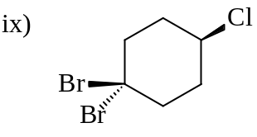
- What are all the stereochemical relations (identical, enantiomers, diastereomers) of the four molecules for which the Fischer projection formulas are given below (e.g., i and ii are _____; i and iii are_____, etc.)? Assign absolute configurations to each asymmetric carbon.
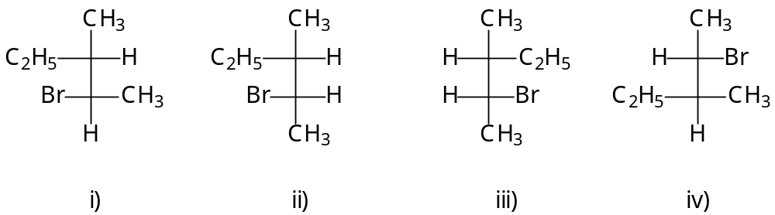

- a. Draw a structural formula for each of the following:
- (E)-3-bromo-2-pentene
- (Z)-3,5R-dichloro-3-heptene
iii. cis-1-fluoro-3S-methyl-1-butene
b. Designate each of the following as (E) or (Z).
i) ii)
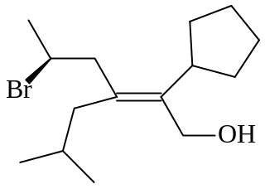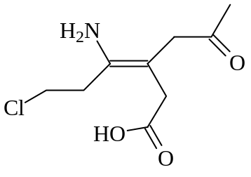

- Shown below are structural diagrams for five pairs of molecules. From the list of five terms (enantiomers, diastereomers, conformers, constitutional isomers, identical), choose the single term that best describes each pair. Note that a term may be used more than once if necessary.
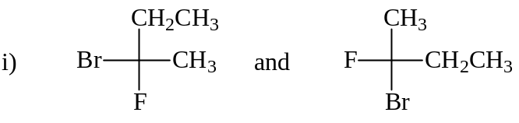
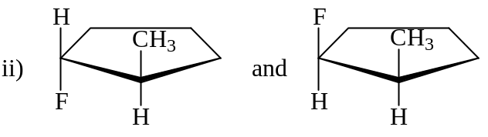
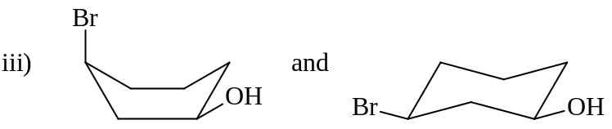
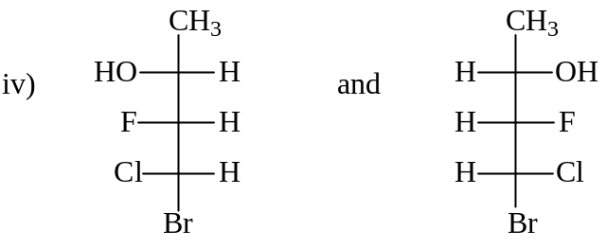
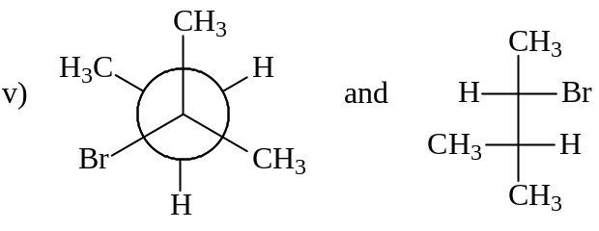
- Assume the drug thalidomide shown below has a specific rotation of [α]_{D} = 59°, a melting point of 271°C, and is insoluble in benzene.

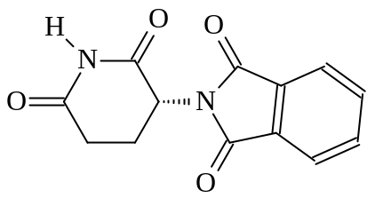
thalidomide

a. Label any stereogenic carbons in this molecule and determine whether
they are (R) or (S).

b. Clearly draw the structure of the enantiomer of thalidomide.

c. Based on what you know, is it possible to predict the specific rotation, melting point, and solubility in benzene of the enantiomer? Explain.

d. What would be the optical activity (if any) of a racemic mixture of (+) and (–) thalidomide?

e. Which term , levorotatory or dextrorotatory would best describe the optical activity (if any) of a 1:2 mixture of (R) : (S) thalidomide?

